PACS ANALYSIS DOCUMENT
APIC– APICORP

TICKET REFERENCE NUMBER : TSR-1092435

ISSUE CREATION DATE : 27-SEP-2025

REOPEN DATE (If Any) : NA

Table of Contents
Table of Contents 2
1. Document History 3
2. Client Information 4
3. Review Information 4
4. Symptoms 4
5. Problem Description 4
6. Analysis 4
7. Alternate Recommendations to the Client 5
8. Steps for Recreation 5
9. Code Analysis 5
10. Code fix Suggestion 5
11. Supporting Screen Prints for the Problem 5
12. Expected Solution to the Problem 5
13. Action to Be Carried Out 6
14. Area details 6

Document History

Author | Version | Date Description
Santhosham.R | 0.1 | 13-NOV-2025 Initial Draft
Vasanth | 1.0 | 13-NOV-2025 Reviewed

Comments:
{Add any comments here}

Client Information

Product : AA
Priority : CRITICAL
Product Release : 202309
System status : LIVE
Database : NA
Front end : BROWSER

Review Information

Analysed By : Santhosham.R
Reviewed By : Vasanth

Symptoms
Schedule showing complete repayment amount

Problem Description
Issue with schedule projection if linear schedule is defined

Analysis
On analysis, we noted that the scenario involves a loan arrangement with just one linear schedule crossed for partial amount.
Now if user trigger change schedule and add one more linear schedule for future date for partial amount, system projects as if the entire outstanding gets collected.
Due to this interest for subsequent period is also displayed wrongly. After crossing the schedule date, system will due the expected amount and gives the correct projection.
At any point time it is expected to give the correct projection.

Alternate Recommendations to the Client
NA

Steps for Recreation
- Consider 202309 environment with latest updates
- Create a back dated loan arrangement and define one schedule for the past period that covers both LINEAR & INTEREST (Refer schedule condition below)
- Trigger LENDING-CHANGE-SCHEDULE effective TODAY and add LINEAR payment for another partial amount to be collected on future date (say 2-3 days from TODAY), this is only for easy replication.
- Check the projection and note that the entire outstanding principal gets projected for the future date
If COB is run to cross the future schedule date, the projection will be fine.

Note : For easy replication, we have given these steps. In client’s case they will have a loan with an INTEREST only schedule falling on the month end, and depending on the requirement, a change schedule will be triggered to collect linear payments on the month end as and when needed.

Code Analysis
Routine : AA.PROJECT.PAYMENT.SCHEDULE.SCHDULES
E.AA.SCHEDULE.PROJECTOR->AA.SCHEDULE.PROJECTOR->AA.PROJECT.SCHEDULE.PROJECTOR->AA.PROJECT.PAYMENT.SCHEDULE.SCHEDULES
For the reported scenario, system fails to give the correct outstanding as per the current logic in AA.PROJECT.PAYMENT.SCHEDULE.SCHEDULES
CASE CALC.TYPE MATCHES "LINEAR":@VM:"ACTUAL":@VM:"OTHER":@VM:"TRANSACTION":@VM:"ADVANCE"
GOSUB CALCULATE.ACCOUNT.AMOUNT
IF PAY.BILL.TYPE EQ 'DISBURSEMENT' THEN
IF NOT(PAYMENT.PERCENT) THEN ;* If Disbursement Schedule defined in Percentage Don't compare Disbursement amount with commitment amount
GOSUB CALCULATE.DISBURSE.AMT ;* Validate disbursement amount if it is greater than commitment amount
** Do not include disbursement schedule amount during the projection when the start date not present in account details. Otherwise system print the deliver message payment schedule details based on double the commitment.
END
UPD.CONTRACT.DETAILS = "" ;* Flag to update the contract details common.
INCLUDE.PRIN.PAYMENT = ""
INCLUDE.PRINCIPAL.PAYMENTS = ""
INCLUDE.PRIN.PAYMENT = R.PAYMENT.SCHEDULE<AA.PaymentSchedule.PaymentSchedule.PsIncludePrinPayments>

IF SCHEDULE.INFO<42> AND INCLUDE.PRIN.PAYMENT THEN
INCLUDE.PRINCIPAL.PAYMENTS = 1 ;* Flag to indicate the call is to update the EB.CASHFLOW record
END

BEGIN CASE
CASE AA.Framework.getContractDetails()<AA.Framework.CdIncludePrinAmounts> EQ "YES" OR INCLUDE.DISBURSE.SCHEDULE OR INCLUDE.PRINCIPAL.PAYMENTS;* Update Contract details with Disbursement Sch. Amount to calculate the Interest when Include Prin Amounts set as Yes.
UPD.CONTRACT.DETAILS = 1
CASE AA.Interest.getRStoreProjection() AND AA.Framework.getAccountDetails()<AA.PaymentSchedule.AccountDetails.AdStartDate>
UPD.CONTRACT.DETAILS = 1
END CASE

IF UPD.CONTRACT.DETAILS THEN
GOSUB UPDATE.CONTRACT.DETAILS
END
END ELSE
GOSUB UPDATE.CONTRACT.DETAILS
END
END CASE

UPDATE.CONTRACT.DETAILS:

*For Deposits & Savings, we need to check the Payment Method before deciding if the Balance amount should be increased or decreased

* while adding the capitalised amount to the outstanding principal, current processing payment type and capitalised payment types will be different.
*Therefore no need to check for holiday amount and holiday date when adding the details of capitalised amount to the outstanding principal
IF NOT(TEMP.CAP.PAYMENT.TYPE) THEN
IF (HOLIDAY.AMOUNT AND HOLIDAY.AMOUNT LE AMOUNT) OR (NOT(HOLIDAY.AMOUNT) AND HOLIDAY.DATE) AND NOT(RESTRICTED.PROPERTY) THEN ;* When the holiday amount less than or equal to calculated amount,assign property amount as holiday amount.
AMOUNT = HOLIDAY.AMOUNT
END

* If the holiday amount is higher than the actual amount, at last for the Account property assign that amount since we can able to define higher holiday amount for the payment type which has account property
IF PAYMENT.PROPERTY.CLASS EQ "ACCOUNT" AND (HOLIDAY.AMOUNT GT AMOUNT) AND NOT(RESTRICTED.PROPERTY) THEN
AMOUNT = HOLIDAY.AMOUNT
END

IF NOT(RESTRICTED.PROPERTY) AND HOLIDAY.AMOUNT THEN ;* When non restricted property comes,decrement the holiday amount from calculated amount to utilise remaining amount for other properties
HOLIDAY.AMOUNT -= AMOUNT
END

IF HOLIDAY.AMOUNT AND HOLIDAY.AMOUNT LE 0 THEN ;* If holiday amount goes less than or equal to zero,then make is as zero
HOLIDAY.AMOUNT = 0
END
END

SAVE.AMOUNT = AMOUNT
BEGIN CASE
CASE PRODUCT.LINE EQ 'DEPOSITS' AND (PAYMENT.METHOD MATCHES "PAY" OR (PAYMENT.METHOD.NEW EQ "PAY" AND PAYMENT.METHOD EQ "MAINTAIN")) ;*Should Decrease the balance
AMOUNT = AMOUNT * (-1)
CASE PRODUCT.LINE EQ 'SAVINGS' AND PAYMENT.METHOD EQ "PAY" ;*Should Decrease the balance
AMOUNT = AMOUNT * (-1)
CASE PRODUCT.LINE EQ 'LENDING' AND PAYMENT.METHOD EQ "PAY" AND (AA.Interest.getRStoreProjection() OR AA.Framework.getContractDetails()<AA.Framework.CdIncludePrinAmounts> EQ "YES" OR INCLUDE.DISBURSE.SCHEDULE OR INCLUDE.PRINCIPAL.PAYMENTS) ;*Should Decrease the balance
AMOUNT = AMOUNT * (-1)
END CASE

IF PAYMENT.DEFER.DATE AND PAYMENT.PROPERTY.CLASS NE "ACCOUNT" THEN
COMPARE.DATE = PAYMENT.DEFER.DATE ;*Add details on the Defer date as this is the date on which accounting will be raised for DUE/PAY/CAP
END ELSE
COMPARE.DATE = PAYMENT.DATE ;*Else take the payment date on which we process accounting entries
END

GOSUB GET.UPDATE.FIELD.NO ;* Populate ContractDetails field positions
GOSUB LOAD.CONTRACT.DETAILS ;* Get updated Values from ContractDetails common

* For a Participant, ProRata amount is calculate and directly updated as outstanding amount
GOSUB CALCULATE.PARTICIPANT.NEXT.OUTSTANDING.AMT ;* Calculate Next Outstanding amount for Participant

* For EXPECTED Bill.Payment.Type on Maturity.Date, dont update the contract details as
* there can be chances that the EXPECTED bill get cancelled, if its unpaid
IF BILL.PAYMENT.TYPE EQ "EXPECTED" AND PAYMENT.DATE EQ MAT.DATE AND NOT(SCHEDULE.INFO<8>) THEN
AMOUNT = 0
END

LOCATE COMPARE.DATE IN TEMP.BAL.EFF<PART.POS,BAL.POS,1> BY "AR" SETTING DATE.POS THEN
IF NOT(IS.PARTICIPANT) THEN ;*Borrower Outstanding amount update
IF NOT(SCHEDULE.INFO<51>) THEN ;* donot update outstanding amount during forward recalc activity... as make due would have already happened with correct outstanding amount.

TEMP.BAL.AMT<PART.POS,BAL.POS,DATE.POS> = TEMP.BAL.AMT<PART.POS,BAL.POS,DATE.POS> + AMOUNT ;* Sign to indicate repayment
END
END ELSE ;*Participant Outstanding amount update
TEMP.BAL.AMT<PART.POS,BAL.POS,DATE.POS> = AMOUNT ;* Update calculatedProRata amount
END
END ELSE
IF NOT(IS.PARTICIPANT) THEN ;*Borrower Outstanding amount update
INS COMPARE.DATE BEFORE TEMP.BAL.EFF<PART.POS,BAL.POS,DATE.POS>
INS TEMP.BAL.AMT<PART.POS,BAL.POS,DATE.POS-1> + AMOUNT BEFORE TEMP.BAL.AMT<PART.POS,BAL.POS,DATE.POS>
END ELSE ;*Participant Outstanding amount update
INS COMPARE.DATE BEFORE TEMP.BAL.EFF<PART.POS,BAL.POS,DATE.POS>
INS AMOUNT BEFORE TEMP.BAL.AMT<PART.POS,BAL.POS,DATE.POS> ;* Update calculatedProRata amount
END
END

AMOUNT = SAVE.AMOUNT
CURR.POS = DATE.POS
LOOP
CURR.POS += 1
WHILE TEMP.BAL.EFF<PART.POS,BAL.POS,CURR.POS>
IF NOT(IS.PARTICIPANT) THEN ;* Borrower OutstandingAmount Update
TEMP.BAL.AMT<PART.POS,BAL.POS,CURR.POS> = TEMP.BAL.AMT<PART.POS,BAL.POS,CURR.POS> + AMOUNT
END ELSE ;* Participant OutstandingAmount Update
TEMP.BAL.AMT<PART.POS,BAL.POS,CURR.POS> = AMOUNT ;* Update calculatedProRata amount
END
REPEAT

IF COMPARE.DATE NE PAYMENT.DATE THEN ;*Get the Present Value as on Payment date's position
LOCATE PAYMENT.FIN.DATE IN TEMP.BAL.EFF<PART.POS,BAL.POS,1> BY "AR" SETTING DATE.POS ELSE
IF DATE.POS GT 1 THEN
DATE.POS -= 1
END
END
END

GOSUB BUILD.CONTRACT.DETAILS ;* Set updated Values in ContractDetails common

IF IS.PARTICIPANT THEN
temp = AA.Framework.getContractDetails()<AA.Framework.CdPartBalAmount>
CONVERT '*' TO @FM IN temp
PARTICIPANT.PRESENT.VALUE<1,PART.POS> = ABS(temp<PART.POS,BAL.POS,DATE.POS>) ;* Reset to AA$CONTRACT.DETAILS at the end of every day
END ELSE
PRESENT.VALUE = ABS(AA.Framework.getContractDetails()<AA.Framework.CdBalAmount,BAL.POS,DATE.POS>) ;*Ensure we reset to AA$CONTRACT.DETAILS at the end of every day
END

RETURN

AA.PROJECT.PAYMENT.SCHEDULE.SCHEDULES:

2417 : IF BAL.DETAILS THEN
TAFJ Debugger-> V BAL.DETAILS
BAL.DETAILS : (-1) 20230331]20230428^]1000^-10000]^-10000]-9000
TAFJ Debugger-> V BALANCE.TO.CHECK
BALANCE.TO.CHECK : (-1) CURACCOUNT
TAFJ Debugger-> V EFFECTIVE.DATE
EFFECTIVE.DATE : (-1) 20230519
TAFJ Debugger->

2423 : END
TAFJ Debugger-> V TEMP.BAL.AMT
TEMP.BAL.AMT : (-1) -10000\-9000
TAFJ Debugger-> V TEMP.BAL.EFF
TEMP.BAL.EFF : (-1) 20230331\20230428
TAFJ Debugger->

2256 : LOCATE PROCESS.DATE IN TEMP.BAL.EFF<PART.POS,BAL.POS,1> BY "AR" SETTING EFF.POS ELSE
TAFJ Debugger-> S

2257 : IF EFF.POS GT 1 THEN
TAFJ Debugger-> S

2258 : EFF.POS -= 1
TAFJ Debugger-> V EFF.POS
EFF.POS : (-1) 3
TAFJ Debugger-> V TEMP.BAL.EFF
TEMP.BAL.EFF : (-1) 20230331\20230428
TAFJ Debugger-> S

2259 : END
TAFJ Debugger-> S

2260 : END
TAFJ Debugger-> V EFF.POS
EFF.POS : (-1) 2
TAFJ Debugger-> S

2265 : IF IS.PARTICIPANT THEN
TAFJ Debugger-> S

2268 : END ELSE
TAFJ Debugger-> S

2269 : PRESENT.VALUE = ABS(TEMP.BAL.AMT<PART.POS,BAL.POS,EFF.POS>) ;* Current outstanding amount, set for each payment date
TAFJ Debugger-> S

2270 : TEMP.ARRID<PART.POS> = ARRANGEMENT.ID
TAFJ Debugger-> V PRESENT.VALUE
PRESENT.VALUE : (-1) 9000
TAFJ Debugger->

6365 : OUTSTANDING.AMOUNT := @FM:PRESENT.VALUE
TAFJ Debugger-> S

6368 : END
TAFJ Debugger-> V PAYMENT.DATE
PAYMENT.DATE : (-1) 20230430
TAFJ Debugger-> V OUTSTANDING.AMOUNT
OUTSTANDING.AMOUNT : (-1) 9000^9000
TAFJ Debugger->

6365 : OUTSTANDING.AMOUNT := @FM:PRESENT.VALUE
TAFJ Debugger-> S

6368 : END
TAFJ Debugger-> V PAYMENT.DATE
PAYMENT.DATE : (-1) 20230430
TAFJ Debugger-> V OUTSTANDING.AMOUNT
OUTSTANDING.AMOUNT : (-1) 9000^9000
TAFJ Debugger->

3909 : FOR YI = 1 TO NO.OF.PAYMENT.PROPERTIES
TAFJ Debugger-> S

3911 : PAYMENT.PROPERTY = SEQUENCED.PROPERTY.LIST<PC.POS,YI> ;* For each property, calculate payment amount
TAFJ Debugger-> S

3913 : IF SKIP.PENALTY.INTEREST AND SKIP.PENALTY.PROPERTY EQ PAYMENT.PROPERTY ELSE
TAFJ Debugger-> S

3915 : SKIM.FLAG = '' ;* Initialise skim flag to NULL for every payment property
TAFJ Debugger-> S

3916 : GOSUB CHECK.SKIM.FLAG ;* Check if the current property is skim property
TAFJ Debugger-> V PAYMENT.PROPERTY
PAYMENT.PROPERTY : (-1) ACCOUNT
TAFJ Debugger->

3974 : PROPERTY.DETAILS<4, PAYMENT.TYPE.POS> = PROGRESS.RATE
TAFJ Debugger-> S

3975 : END
TAFJ Debugger-> V PROPERTY.DETAILS
PROPERTY.DETAILS : (-1) LINEAR-ACCOUNT^^INSTALLMENT^
TAFJ Debugger->

4021 : IF CALC.TYPE EQ "PROGRESSIVE" THEN ;*For Progressive type
TAFJ Debugger-> V CALC.TYPE
CALC.TYPE : (-1) LINEAR
TAFJ Debugger-

4028 : GOSUB PROCESS.PROPERTY.CLASS ;* Continue if flag is set
TAFJ Debugger-> s

4154 : HOLIDAY.DATE = "" ;* Initialise for each Properyt Class
TAFJ Debugger-> S

4155 : PAYMENT.PROPERTY.CLASS = PROPERTY.CLASS.TO.PROCESS<PC.POS> ;* From class determine how to calculate
TAFJ Debugger-> S

4157 : LAST.ACCRUAL.DATE = ""
TAFJ Debugger-> S

4158 : PAYMENT.PROPERTY.AMOUNT = 0 ;* Reset amounts
TAFJ Debugger-> S

4159 : PAYMENT.PROPERTY.POS.AMOUNT = 0 ;* Reset amounts
TAFJ Debugger-> S

4160 : PAYMENT.PROPERTY.NEG.AMOUNT = 0 ;* Reset amounts
TAFJ Debugger-> V PAYMENT.PROPERTY.CLASS
PAYMENT.PROPERTY.CLASS : (-1) ACCOUNT
TAFJ Debugger->

5713 : REMAIN.AMOUNT = TEMP.VALUE - RESIDUAL.AMOUNT ;* any bill types other than above three should not be taken to update the amount
TAFJ Debugger-> S

5728 : END CASE
TAFJ Debugger-> V REMAIN.AMOUNT
REMAIN.AMOUNT : (-1) 9000
TAFJ Debugger-> V RESIDUAL.AMOUNT
RESIDUAL.AMOUNT : (-1)
TAFJ Debugger-> V TEMP.VALUE
TEMP.VALUE : (-1) 9000
TAFJ Debugger->

6035 : IF CALCULATED.TYPE THEN ;* For linear type advance schedules, the CALC.AMOUNT will be the full linear payment amount
TAFJ Debugger-> S

6037 : END ELSE
TAFJ Debugger-> S

6038 : ACCOUNT.AMOUNT.CHECK = PAYMENT.AMOUNT.LIST<1,PAY.TYPE.I>
TAFJ Debugger-> S

6039 : END
TAFJ Debugger-> V PAYMENT.AMOUNT.LIST
PAYMENT.AMOUNT.LIST : (-1) 2000.00
TAFJ Debugger->

5837 : tmp.R$STORE.PROJECTION = AA.Interest.getRStoreProjection()
TAFJ Debugger-> S

5838 : IF REMAIN.AMOUNT AND (REMAIN.AMOUNT LT ACCOUNT.AMOUNT.CHECK) AND NOT(tmp.R$STORE.PROJECTION) THEN
TAFJ Debugger-> S

5840 : END
TAFJ Debugger-> V REMAIN.AMOUNT
REMAIN.AMOUNT : (-1) 9000
TAFJ Debugger-> V ACCOUNT.AMOUNT.CHECK
ACCOUNT.AMOUNT.CHECK : (-1) 2000.00
TAFJ Debugger->

5842 : IF PROCESS.RESIDUAL THEN
TAFJ Debugger-> S

5845 : ZERO.PRINCIPAL.POS = PAY.DATE.I
TAFJ Debugger-> S

5846 : IF TEMP.VALUE GE RESIDUAL.AMOUNT THEN
TAFJ Debugger-> S

5847 : AMOUNT = TEMP.VALUE - RESIDUAL.AMOUNT
TAFJ Debugger-> V TEMP.VALUE
TEMP.VALUE : (-1) 9000
TAFJ Debugger-> V RESIDUAL.AMOUNT
RESIDUAL.AMOUNT : (-1)
TAFJ Debugger-> S

5850 : END
TAFJ Debugger-> V AMOUNT
AMOUNT : (-1) 9000
TAFJ Debugger->

6239 : LOCATE COMPARE.DATE IN TEMP.BAL.EFF<PART.POS,BAL.POS,1> BY "AR" SETTING DATE.POS THEN
TAFJ Debugger-> S

6248 : END ELSE
TAFJ Debugger-> S

6249 : IF NOT(IS.PARTICIPANT) THEN ;*Borrower Outstanding amount update
TAFJ Debugger-> S

6250 : INS COMPARE.DATE BEFORE TEMP.BAL.EFF<PART.POS,BAL.POS,DATE.POS>
TAFJ Debugger-> S

6251 : INS TEMP.BAL.AMT<PART.POS,BAL.POS,DATE.POS-1> + AMOUNT BEFORE TEMP.BAL.AMT<PART.POS,BAL.POS,DATE.POS>
TAFJ Debugger-> S

6255 : END
TAFJ Debugger-> S

6256 : END
TAFJ Debugger-> V TEMP.BAL.AMT
TEMP.BAL.AMT : (-1) -10000\-9000\0
TAFJ Debugger-> V AMOUNT
AMOUNT : (-1) 9000
TAFJ Debugger->

6715 : AA.Framework.setContractDetails(Contractdetails)
TAFJ Debugger-> S

6717 : RETURN
TAFJ Debugger-> s

6280 : IF IS.PARTICIPANT THEN
TAFJ Debugger-> V Contrcatdetails
Contrcatdetails : N/A
TAFJ Debugger-> V Contractdetails
Contractdetails : (-1) ^^CURACCOUNT^20230331\20230428\20230522^-10000\-9000\0^^^^^AA231399M0GV
TAFJ Debugger->

6285 : PRESENT.VALUE = ABS(AA.Framework.getContractDetails()<AA.Framework.CdBalAmount,BAL.POS,DATE.POS>) ;*Ensure we reset to AA$CONTRACT.DETAILS at the end of every day
TAFJ Debugger-> S

6286 : END
TAFJ Debugger-> S

6288 : RETURN
TAFJ Debugger-> V PRESENT.VALUE
PRESENT.VALUE : (-1) 0
TAFJ Debugger->

4486 : IF PAYMENT.MODE EQ "ADVANCE" THEN ;* Check Payment Mode is advance then set the position of current date
TAFJ Debugger-> V PAYMENT.DATE
PAYMENT.DATE : (-1) 20230522
TAFJ Debugger-> V PAYMENT.PROPERTY.AMOUNT
PAYMENT.PROPERTY.AMOUNT : (-1) 9000
TAFJ Debugger->

6364 : IF OUTSTANDING.AMOUNT NE "" THEN
TAFJ Debugger-> S

6365 : OUTSTANDING.AMOUNT := @FM:PRESENT.VALUE
TAFJ Debugger-> V PRESENT.VALUE
PRESENT.VALUE : (-1) 0
TAFJ Debugger-> S

6368 : END
TAFJ Debugger-> V OUTSTANDING.AMOUNT
OUTSTANDING.AMOUNT : (-1) 9000^9000^0
TAFJ Debugger->
Output: AA.PROJECT.PAYMENT.SCHEDULE.SCHDULES
TAFJ Debugger-> V SCHEDULE.INFO
SCHEDULE.INFO : (-1) AA231399M0GV^20230519^SCHEDULE^LENDING-CHANGE-SCHEDULE]UPDATE]20230331]]]]]]]DISBURSEMENT.%\INTEREST\LINEAR\LINEAR]PAY\DUE\DUE\DUE]\e0Y e1M e0W e0D e0F\\]\\\]\]\]\]ACCOUNT\PRINCIPALINT\ACCOUNT\ACCOUNT]\e0Y e1M e0W e0D e0F\\]100\\\]R_START\\D_20230430\D_20230522]\\\]\\\]\\9000.00\9000.00]\\1000.00\2000.00]]\]\]\]\]DISBURSEMENT\INSTALLMENT\INSTALLMENT\INSTALLMENT]\\\]\]\\\]\\\]\]\\\]]]YES]LENDING-DISBURSE-COMMITMENT\LENDING-CHANGE-SCHEDULE\LENDING-CHANGE.TERM-COMMITMENT\LENDING-AUTO.DISBURSE-COMMITMENT\LENDING-CHANGE-PRINCIPALINT\LENDING-CHANGE.CONDITION-PRINCIPALINT\LENDING-ADVANCE.RESET-PRINCIPALINT\LENDING-ADVANCE.CHANGE-PRINCIPALINT\LENDING-PERIODIC.RESET-PRINCIPALINT\LENDING-DEFINE.HOLIDAY-SCHEDULE]PAYMENT\PAYMENT\PAYMENT\PAYMENT\PAYMENT\PAYMENT\PAYMENT\PAYMENT\PAYMENT\TERM]]LENDING-SETTLE-PR.REPAYMENT]]]]]]]]]]]]]]]]]]]]]]]]]]]]]]]]]]]]]]]PAYMENT.TYPE\PAYMENT.METHOD\PAYMENT.FREQ\PROG.PAY.PERC\RESERVED.17\PROPERTY\DUE.FREQ\PERCENTAGE\START.DATE\END.DATE\NUM.PAYMENTS\ACTUAL.AMT\BILL.TYPE\BILL.PRODUCED\DEFER.PERIOD\FINALISE.BILL\REFER.SCHEDULE\ISSUE.BILL]PAYMENT.TYPE\PAYMENT.METHOD\PAYMENT.FREQ\PROG.PAY.PERC\RESERVED.17\PROPERTY\DUE.FREQ\PERCENTAGE\START.DATE\END.DATE\NUM.PAYMENTS\ACTUAL.AMT\BILL.TYPE\BILL.PRODUCED\DEFER.PERIOD\FINALISE.BILL\REFER.SCHEDULE\ISSUE.BILL]AA231399M0GV]SCHEDULE]20230519.1]]]]]]]]]1]207_INPUTTER__OFS_BROWSERTC_AAACT2313992SMVW04]2511121105]207_INPUTTER_OFS_BROWSERTC_AAACT2313992SMVW04]GB0010001]1^^^^1^20230519\^^^^^^^20230522^^^^^^^^^^^^^^^^^^^^^^
TAFJ Debugger-> V OUTSTANDING.AMOUNT
OUTSTANDING.AMOUNT : (-1) 9000^9000^0^0^0^0^0^0^0^0^0^0^0^0
TAFJ Debugger-> V PAYMENT.DATES
PAYMENT.DATES : (-1) 20230331^20230430^20230522^20230530^20230630^20230730^20230830^20230930^20231030^20231130^20231230^20240130^20240229^20240329
TAFJ Debugger-> V PAYMENT.PROPERTIES.AMT
PAYMENT.PROPERTIES.AMT : (-1) ^^9000^13.74^0^0^0^0^0^0^0^0^0^0
TAFJ Debugger->

Output AA.PROJECT.SCHEDULE.PROJECTOR:
1634 : IF PRODUCT.LINE = 'LENDING' THEN
TAFJ Debugger-> S

1635 : PRESENT.VALUE = NEGS(PRESENT.VALUE)
TAFJ Debugger-> S

1636 : END
TAFJ Debugger-> S

1638 : FutureSchedules = 1 ;* FutureSchedules is set to indicate Future scheduled bills are being processed
TAFJ Debugger-> S

1640 : GOSUB CONSOLIDATE.DATES ;* Parse the Projection Details
TAFJ Debugger-> S

1642 : RETURN
TAFJ Debugger-> V DUE.OUTS
DUE.OUTS : (-1) -10000^-9000^0^0^0^0^0^0^0^0^0^0^0^0
TAFJ Debugger-> V DUE.DATES
DUE.DATES : (-1) 20230331^20230430^20230522^20230530^20230630^20230730^20230830^20230930^20231030^20231130^20231230^20240130^20240229^20240329
TAFJ Debugger-> V DUE.PROP.AMTS
DUE.PROP.AMTS : (-1) 100]10000^20.82]1000^9000^13.74^0^0^0^0^0^0^0^0^0^0
TAFJ Debugger-> V DUE.PROPS
DUE.PROPS : (-1) NEWARRFEE]ACCOUNT^PRINCIPALINT]ACCOUNT^ACCOUNT^PRINCIPALINT^PRINCIPALINT^PRINCIPALINT^PRINCIPALINT^PRINCIPALINT^PRINCIPALINT^PRINCIPALINT^PRINCIPALINT^PRINCIPALINT^PRINCIPALINT^PRINCIPALINT
TAFJ Debugger->

Code fix Suggestion
NA

Supporting Screen Prints for the Problem

DATES:
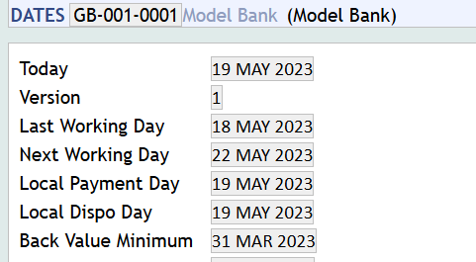
New loan created effective 31march, linear schedule defined for partial amount(1000 for 30 apr)
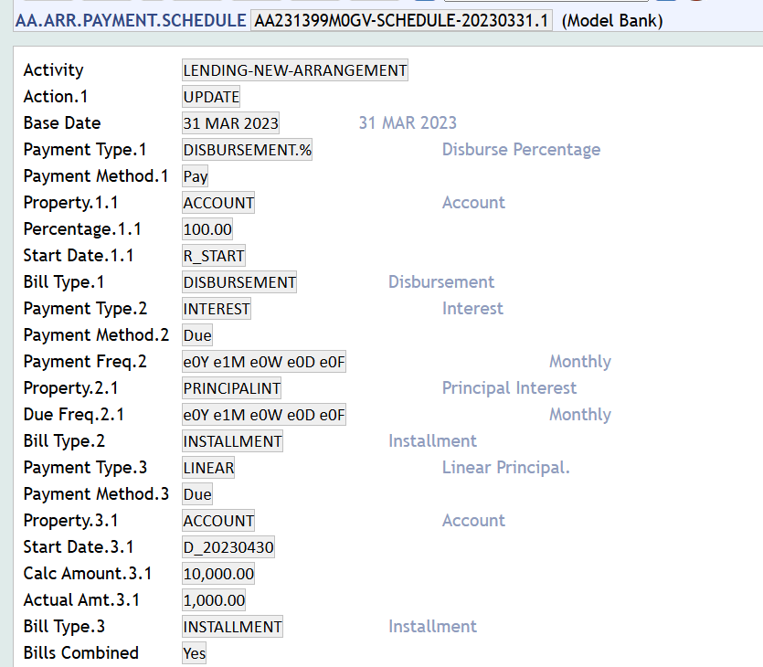

Trigger change schedule effective today, add another linear payment for the future and partial amount(2000 , 22 MAY 2023)
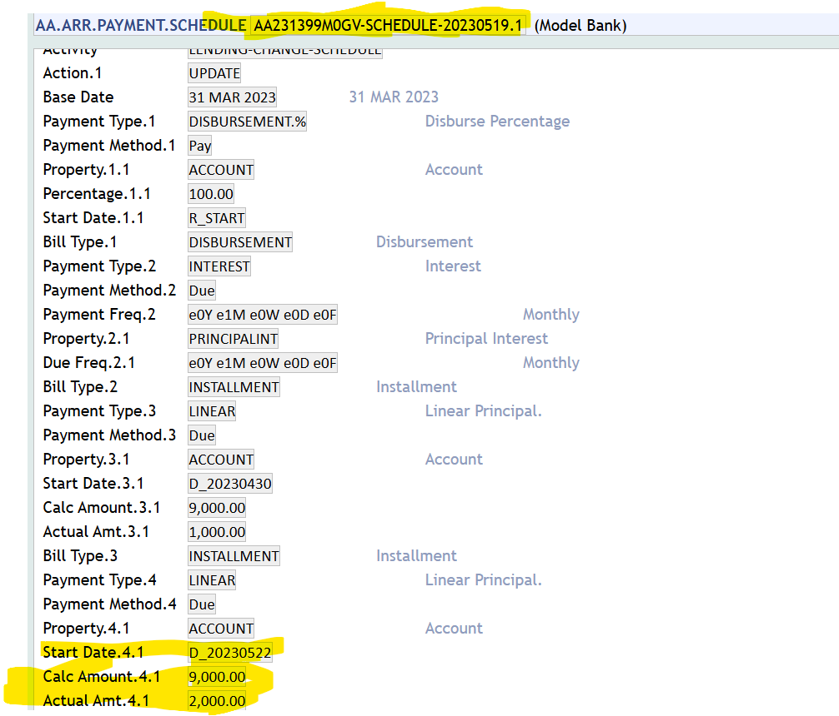

Check the projection:
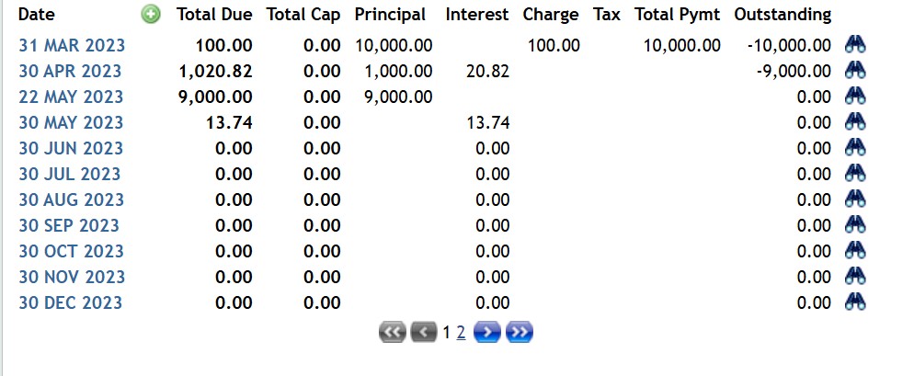

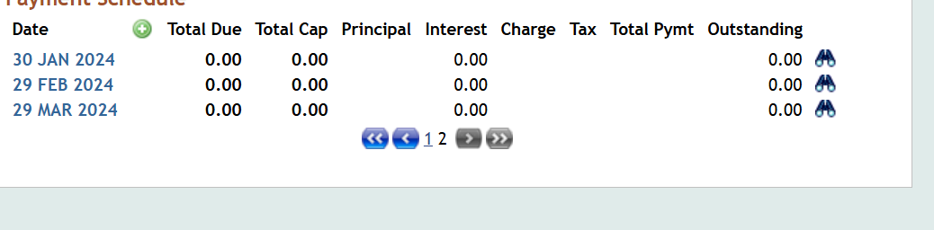

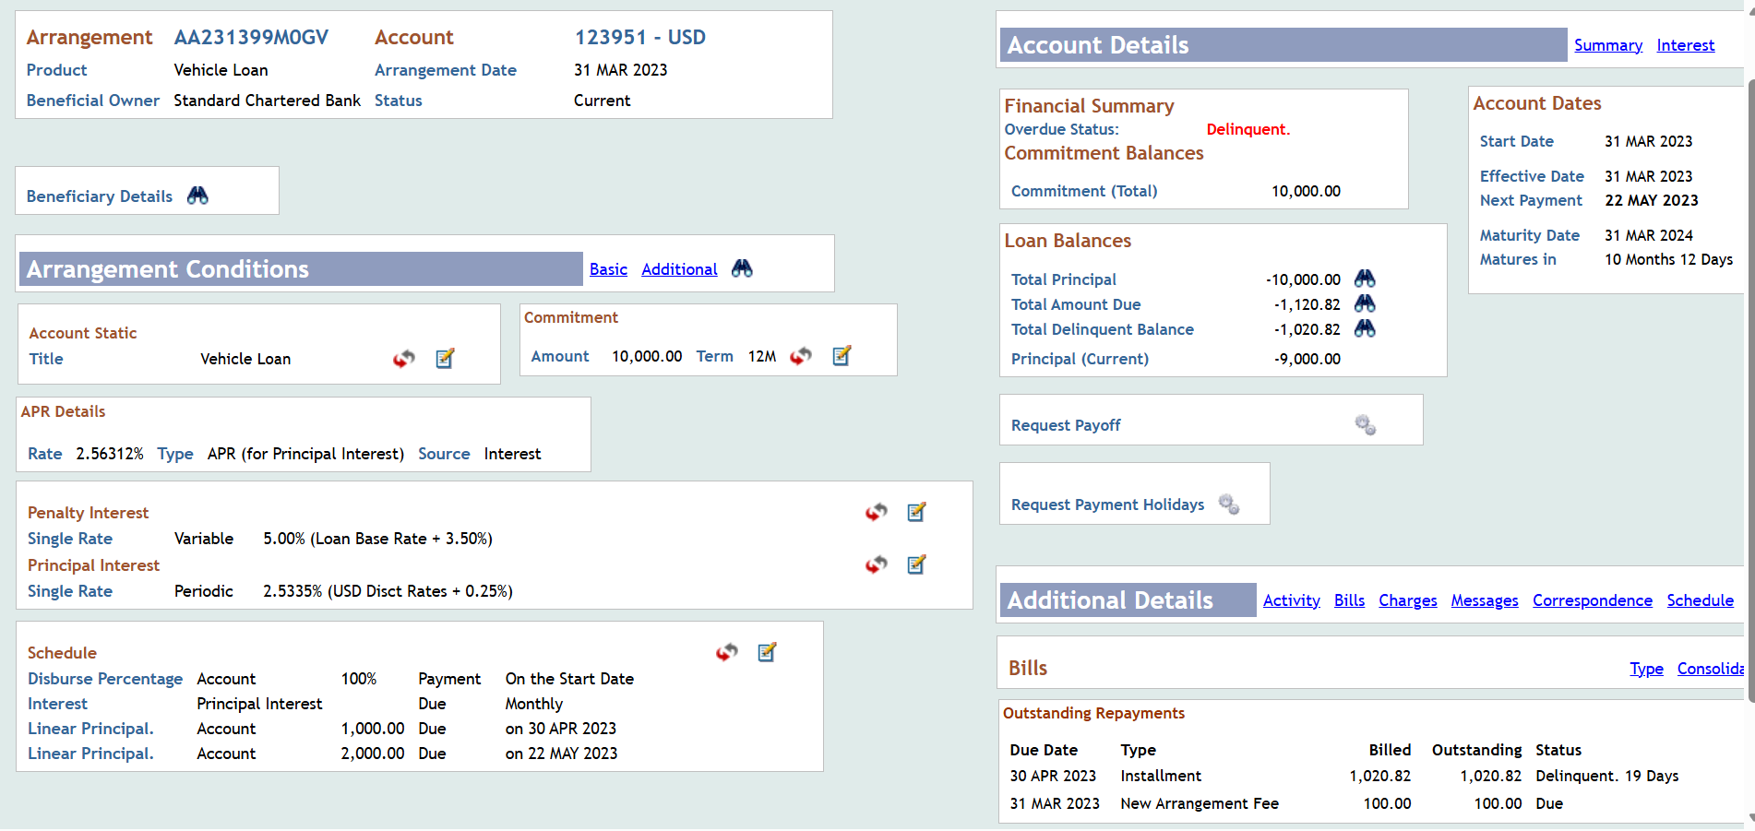

AA.ACTIVITY.HISTORY:
Run cob to reach 22nd May:
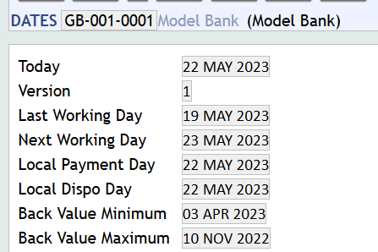

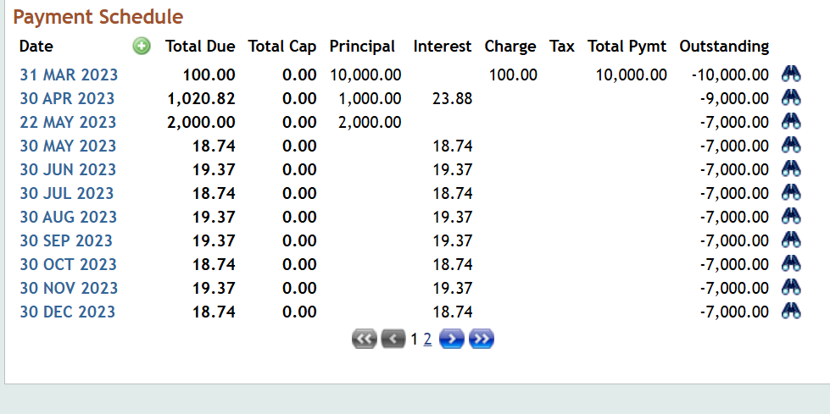

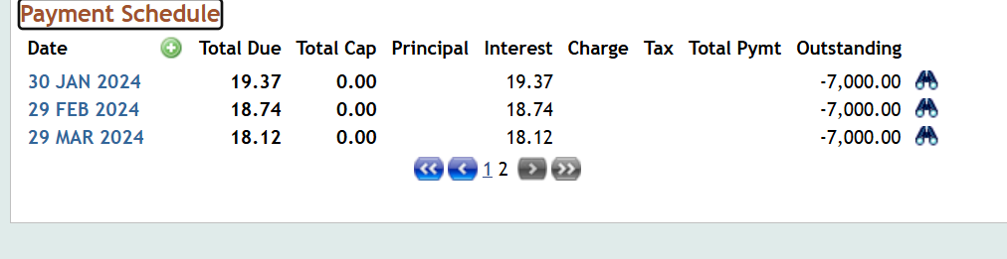

Expected Solution to the Problem
System should give correct projection for the scenario reported.

Action to Be Carried Out
This issue is classified as a bug. Hence moving this to maintenance for a solution or fix.

Area details
Server Information :
User name :
Password :
Backup available until :
Tar Backup Details :

*Template History (in footer) only applicable for templates and checklists

